❑ Let’s design following Facebook Post card using your learnt tips

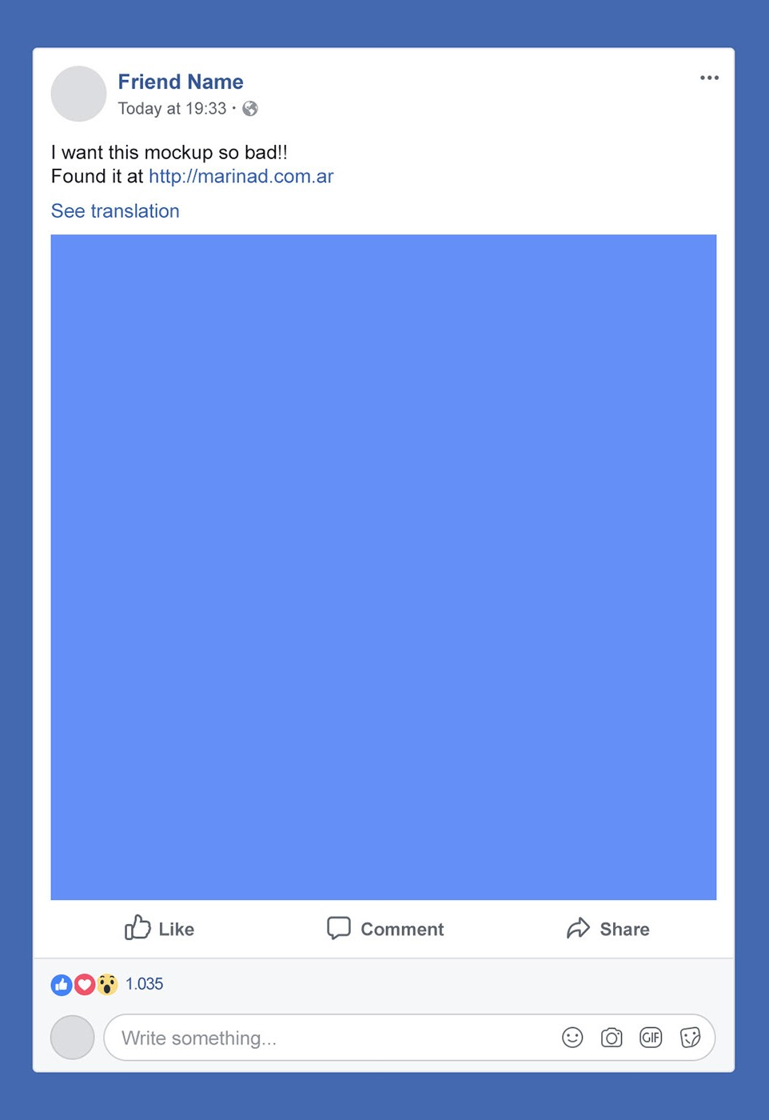

# Row-column layout tips

❑ Let’s design following Facebook Post card using your learnt tips ▪ You have to firstly define your row-column

layout before doing something else



**Newsfeed**

**Item**

**)**

**(**

**Element**

**comment section**

**Reaction total**

**Like button**

**Comment button**

**Share button**

**Profile section**

# Row-column layout tips

❑

Row and column with Flex layout



flex

-

grow

-

0

flex

-

grow; flex

flex

-

grow

-

; flex

0

flex; flex

-

col

?

?

?

?

?

?

?

?

?

?

Ex01

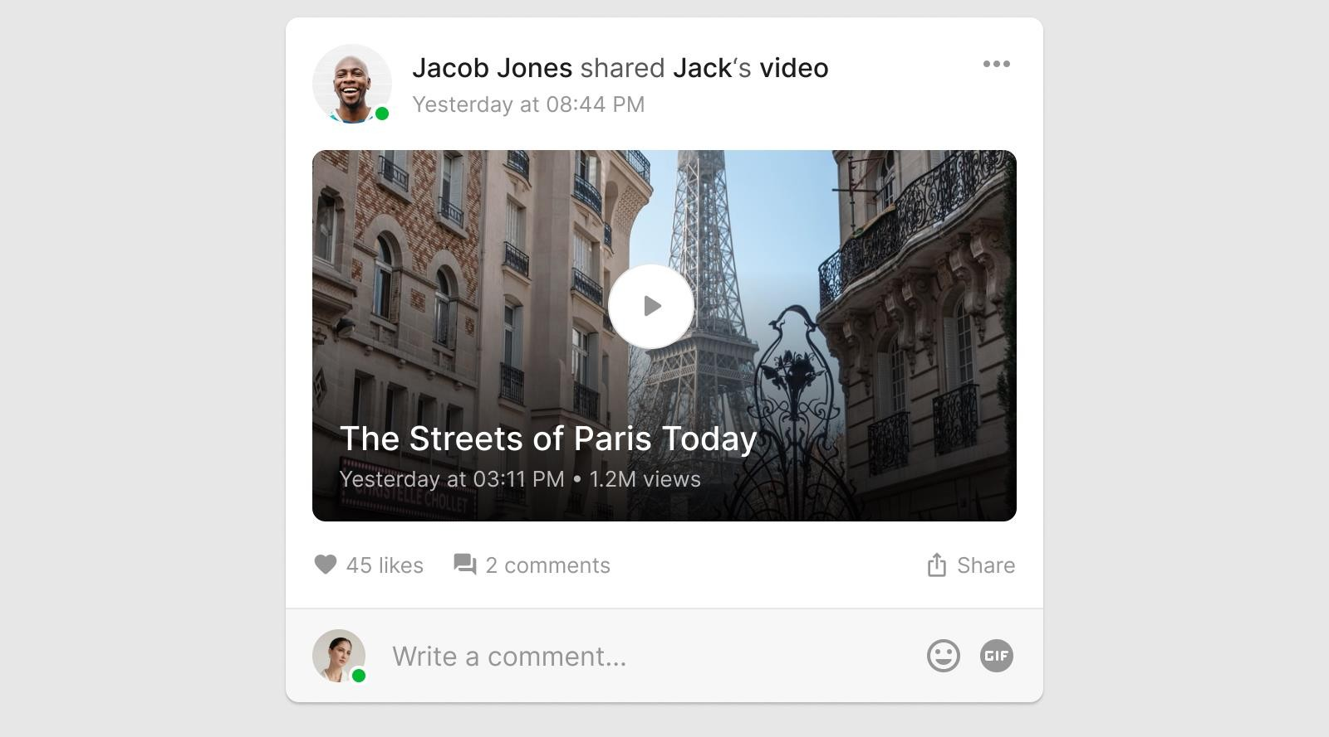

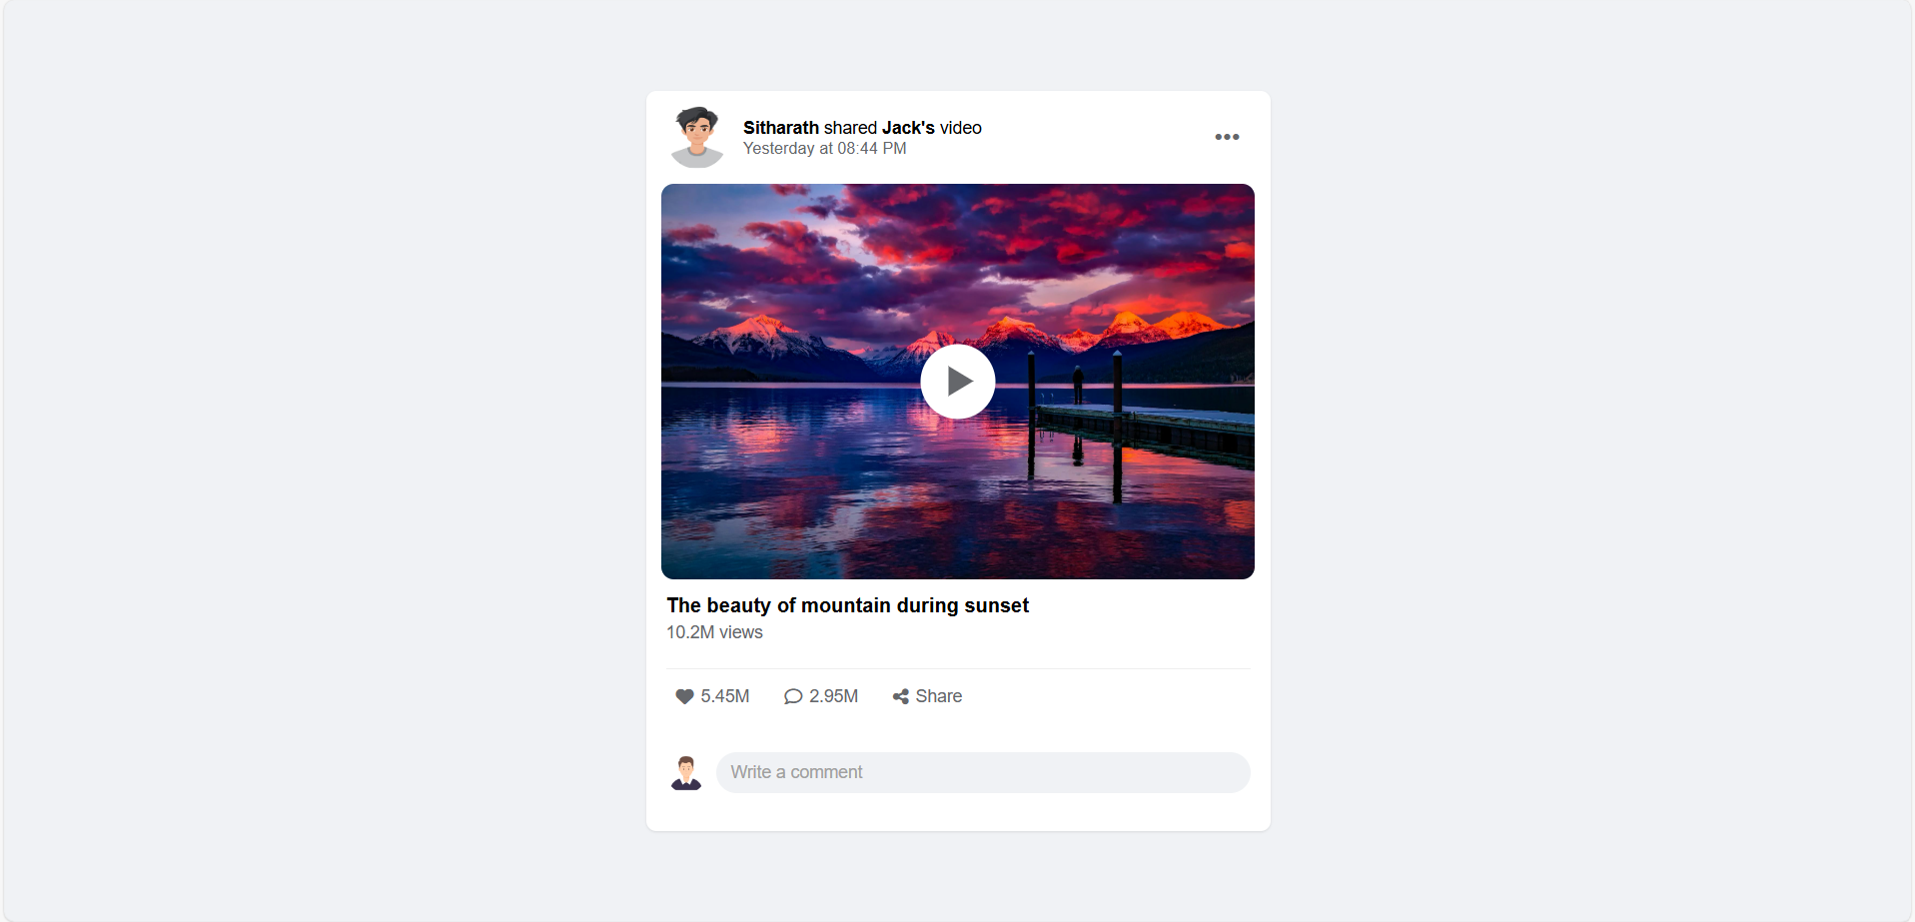

Ex02

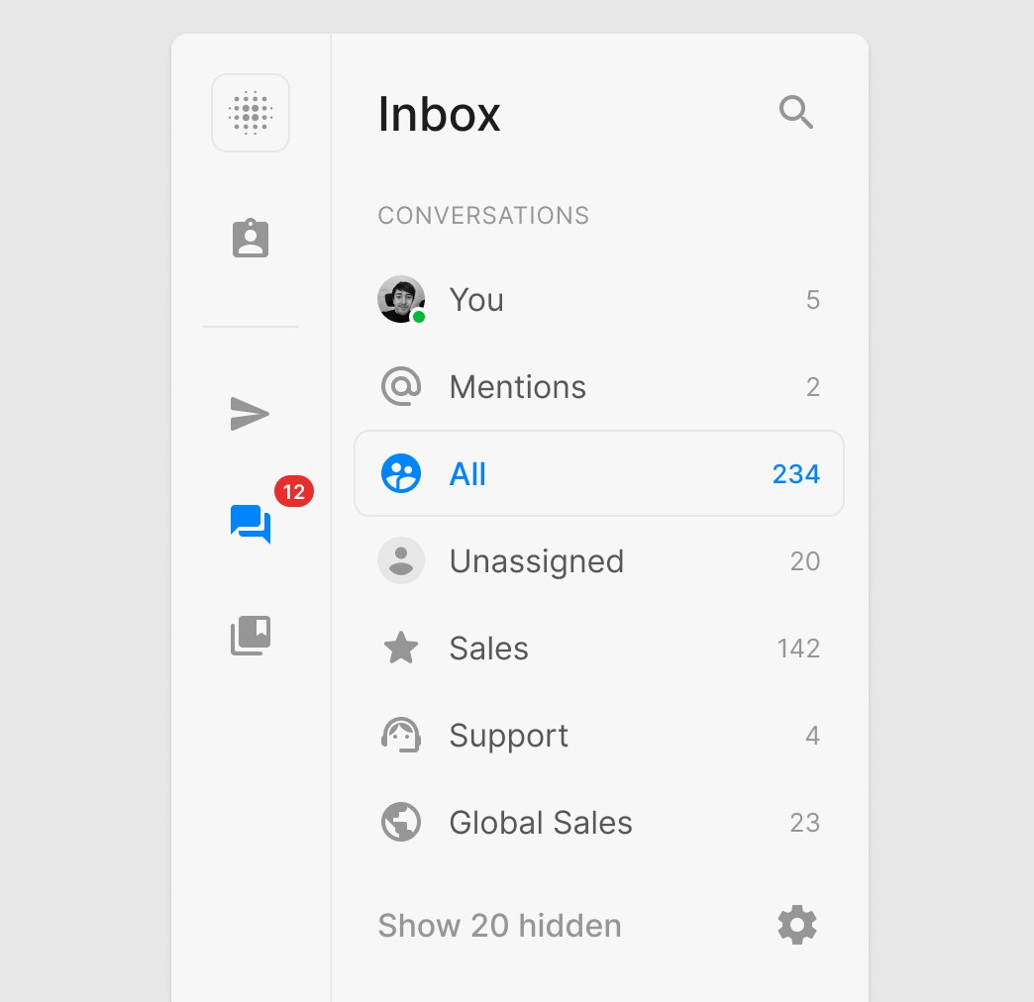

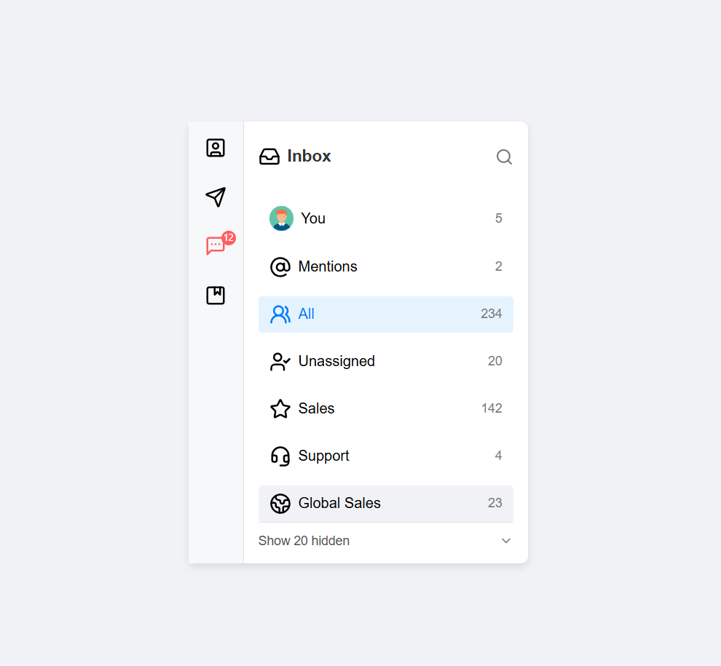

Ex03

